To

Sub: Application for the position

Sir,
With due respect and humble submission, I would like to inform you that I am so much interested to your organization that’s why I want to offer myself is an employee of suitable post. I would be very grateful to you if you selected me as an employee for your organization. I believe I am perfect fit for the position. I am very reliable and detailed oriented. I organized my time and work very effectively and efficiently.

Therefore, I will be very indebted if you give me the opportunity to the work in your organization and bear out my potentiality.

Sincerely yours
Md. Rashidul Islam

Enclosed:
1. A complete CV
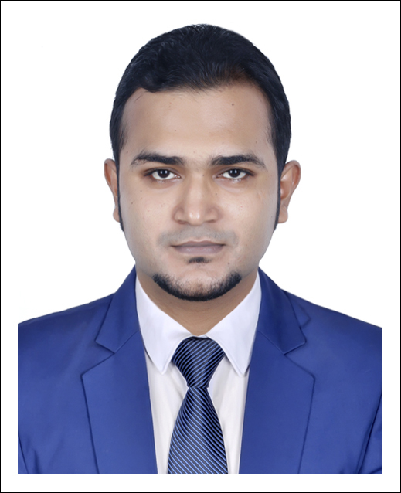
Curriculum Vitae of
MD. RASHIDUL ISLAM

MAILING ADDRESS

Address | : | House no. 23,Road no.18,Nikunja-2, Khilkhet, Dhaka-1229
Cell Phone | : | +88 01671-447457, +88 01722-203422
E-mail | : | rashedsr034@gmail.com

CAREER OBJECT
I have a passion for learning and work in a challenging environment where I have a real chance to use my skill, experience and can work my mutual value adding exercise.
WORK EXPERIENCE
Company Name: Digicon Technologies Ltd
Job Position: Customer Service Specialist (Grameenphone Process)
Duration: 02 May, 2016 to 04 April 2019
Company Name: Nitol Niloy Group
Job Position: Executive Officer (Amaar Hero NML)
Niloy Motors Ltd.
Duration: 10 Dec. 2019 to Running
JOB RESPONSIBILITIES
*Handle Inbound/Outbound Calls of Premium customers with instant satisfaction by providing information and service solution.
*To make understand about the products, processes and policies of Grameenphone to customer.
*To get customer feedback about Grameenphone take opinions of customer by interacting with a call to them.
*Inform all the details feedback of customers as a report to the respective authority.
*Any other responsibility as assigned by the Company.
ACHIEVEMENT
- Certificate of Achievement : Outstanding performance Star of the month July ,18
- Certificate of Appreciation : Meet and Greet Program, Awarded 30.01.2018
- Certificate of Appreciation : Outstanding Service under the project “GOAL-2018”
- Certificate of Appreciation : Extra Outstanding Service under the project “GOAL-2018”
PERSONAL INFORMATION
Date of Birth | : | 25 December, 1990
Father’s Name | : | Md. Shamsher Ali
Mother’s Name | : | Hosneara
Nationality | : | Bangladsehi
National ID No | : | 19909314783000035
Blood Group | : | B+
Gender | : | Male
Marital Status | : | Unmarried

EDUCATIONAL QUALIFICATIONS

Examination | Subject/ Group | University/ Institution | Year of Passing | Division/Grade
Bachelor of law | LL.B (Hon’s) | Southeast University | 2015 | 2.52 ( out of 4)
H.S.C. | Arts & Social science | Kalihati College | 2009 | 3.60 out of 5.00
S.S.C. | Science | Kalihati R S Pilot High School | 2007 | 3.38 out of 5.00

COMPUTER SKILL
- Office Program (MS- Word, MS-Excel, MS- PowerPoint)
- Internet Browsing
- E-Mail Function.

LANGUAGE PROFICIENCY

Language | Speaking | Reading | Writing
Bengali | Excellent | Excellent | Excellent
English | Moderate | Excellent | Excellent

ADDITIONAL INFORMATION

  - Strong communication skill.
  - Highly motivated to work with a team.
  - Motivated to work under stressed conditions.
  - Hard working & able to undertake challenges.
  - Well planner.
NAME OF THE REFEREE
Tasmia Prodhan  Barrister-at-Law (Lincoln’s lnn)  Advocate, Supreme Court of Bangladesh  Road #1, House #2, Asad Avenue , Block –A  Mohammadpur,Dhaka -1207, Bangladesh  Mobile No.: +88 01552-638110  E-mail: barristerprodhan@yahoo.com  Court Chamber : Room # 703 (Annex) Supreme court Bar Association Building. | Rabeya Begum  Judicial Magistrate  Chip Judicial Magistrate Court,Bagherhat.  E-mail: rabeya57@yahoo.com  Mobile No. +88 01676-260153  Sorui, Bagherhat
I hereby declare that the above statements are correct and complete to the best of my knowledge.
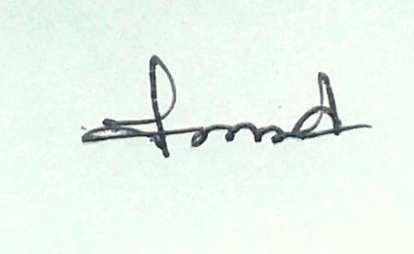
-

----------------------------
Md. Rashidul Islam

